Name: _________________________ Score: _________________

1. Whenever an Opportunity is Closed Won then Post the amount of opportunity with opportunity link in the related Account’s feed.
2. Show the Subject of Last Case Attached to Account in the Account Section called Latest Case Details.
3. 360 Degree Cloud has a product called SMS App which the company sells at USD 50 in US, USD 20 in India and USD 30 in UK. The company has decided to use salesforce.com now and is confused on how to handle this scenario. Create this product and set the same so that sales people can sell the product at its listed price in those countries
4. 360DC has implemented 3 recordtypes on case i.e. Implementation Case, Billing Case and Resolved Case. The company does not want to give the choice of selection to the support Reps. The support Rep should always create the Case with RecordType of Implementation case and in the case there is a dropdown with type with value Resolved, Billing. The record type should get changed based on the value being selected.
5. 360Dc wants to send the email to a contact linked with case if the case is open for more than 30 min. Email should say: Sub : Case still Open Desc : Hello {Client name} We are woking on your case and will resolve the same ASAP
6. Create a case with “web to case” values : Subject, Description, Email, Mobile. If the contact exists with that Email Id then link the case to the contact of the email Id.
7. 360DC Sales Manager wants to see list of all Open (overdue) Tasks send to him in morning so that he can plan his day.
8. 360Dc wants that any Task which is not completed on the due date should be marked with Status “Missed” automatically.
9. Open Opportunities by Created Date

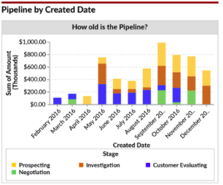

1. 360 Dc has a constant complaint about sales reps giving a lot of discounts. To mange the same 360Dc wants an Auto Approval if the discount is less than 10% else it goes to the manager for the approval.
2. 360DC is very strict about security and their oppty should be visible only to owner of the oppty. The sales manager wants to create a new user lookup field “Help Required”. Whatever the name will be in that field, the opportunity should be visible to that particular user also.